Wac Arts Summer Programmes 2019
Application Form
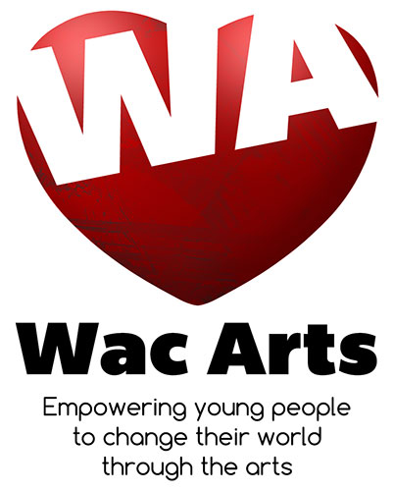

Deadline for application: First Come First Serve. Places allocated by: 22nd July 2019.

What’s on offer:
Please tick which course(es) you would like to do:
Circus School:5yrs - 12yrs from 24th July – 27th July 2019 10:00am to 3:30pm

Digital Theatre (Fully Inclusive): 14yrs – 26yrs from 5th – 9th August 2019 10:00am to 3:30pm

‘Summer Songbirds’ Creative Singing Sessions for Children Summer School: 8yrs – 12yrs from 12th August – 16th August 2019 10:30am to 3:30pm

Dance Fusion Summer School: 13yrs - 19yrs from 19th – 23rd August 2019 10:00am to 3:30pm

How much it costs:
Circus School £50.00 & Singing: £60.00 for the full week.
Dance Fusion & Digital Theatre: Free
If 2 siblings would like to join the same course, a place for the first child costs full price and the second is half price. For Circus School full price is £50 for first child and £25 for the second child (i.e. total of £75 for two children from the same family). For Singing programme full price is £60 for first child and £25 for the second child (i.e. total of £85 for two children from the same family).

Would you like to be considered for Bursaries? Yes No If Yes, how many? __________
Half and full bursaries are available. Please refer to the attached explanation of the process.
Are you in receipt of any state benefits? Yes No
If Yes, please specify which state benefit(s) you are in receipt of:
_________________________________________________________________________________
Are you applying for a sibling discount? Yes No If yes, please specify sibling name_____________________

Payment:
We are transitioning to a cashless payment system and are asking for all fees to be paid in advance by bank account (BACS) transfer.
To make a payment please send us the completed application form, and we will send you our bank details. Should you wish to pay by cash, please contact us on our main reception at 020 7692 5800. For cheque payments, simply send a cheque along with the application form.

How would you like to make your payment? Bank Transfer Cheque Cash

About you…(please turn over)
First Name: |  |  | Last Name:
Age: | D.O.B: | Gender:
Address: |  | Postcode: |  | Borough: |  | Electoral Ward (if known):
Home Phone: |  | Mobile: |  |  | Email:
Which School/College/Uni do you attend?

Please tell us in a few words, why you or your child would like to take part in the Wac Arts summer programme:

As we are a performing arts & media college we often use photographs, video footage for publicity and / or screening purposes.
Please read the statement below, and sign to confirm your consent.
I confirm that I agree to Wac Arts taking photos, videos and audio recordings for use on its websites, social media, promotional materials, publications and press releases.
I give permission for me/my child to be: (Please tick as applicable)

Photographed ◻ Filmed ◻ Audio Recorded ◻

All Wac Arts records are stored under reasonable security and can only be accessed by Wac Arts staff. Wac Arts is registered with the information commissioner as per our Privacy statement. From time to time we may contact you regarding our programme or courses. We will not pass on personal information.

And finally…
Help us reach even more young people by telling us how you heard about Wac Arts (give us specific information e.g., the contact who told you about us, which social media platform, if it was an advert where di did you see it, etc):

Parent/Carer’s name: _________________________ Signature: ___________________

Today’s date

Please return your application form to:
Jitendra Kulkarni
Wac Arts
Old Town Hall
213 Haverstock Hill
London NW3 4QP

Thank you for your application. Wac Arts programmes are famously inclusive and diverse, and we expect more applications than we have places. Submitting this application, together with your payment, will secure you/your child a place. Places will be allocated carefully on a first come, first served basis, but also recognise the circumstances, needs, talents and/or abilities of young people. Places will be allocated by 21st July 2019 at the very latest. Should the programmes become fully booked and we are not able to allocate you a place, you would have the choice to remain on the waiting list in case spaces come up nearer the time. If you/your child are allocated a place you/they will be expected to attend every day/session, on time. If you have any questions at all about our application process or the courses, please contact our programme administrator at Jitendra.Kulkarni@WacArts.co.uk or on 020 7692 5888

Equal Opportunities Monitoring Form
As we are required by our funders to obtain the below information, please assist us by ticking the appropriate box(es). None of this information impacts on your eligibility on the course

How would you describe yourself (please tick all that apply)?

Do you/your child have a disability? | Yes ☐ | No ☐
Do you/your child have any additional requirements? I.e. learning or medical requirements? | Yes ☐ | No ☐
If yes please provide further details

It is essential that you inform us of any special needs and/or disabilities your child may have. Should we find there are additional support needs that have not been declared, we may be unable to engage your child on the programme due to limited resources.

Please circle the option that best describes your ethnicity:
White | 1 British  2 Irish  3 Other – Please state  ________________________ | Black/ Black British | 12 Caribbean  13 African  14 Other – Please state  _____________________
Mixed | 4 White & Black Caribbean  5 White & Black African  6 White & Asian  7 Other – Please state  ________________________ | Chinese or other ethnic group | 15 Chinese  16 Other – Please state  _____________________
Asian/ Asian  British | 8 Indian  9 Pakistani  10 Bangladeshi  11 Other – Please state

